**Session 1**

1. Linked lists

Linked List is a linear ds in which elements are stored as per the memory availability.

A linked list is a sequence of data structures that can store a collection of items which are connected together via links. Each link contains a connection to another link. Linked list is the second most-used data structure after array.

LL size is Dynamic and we can easily insert and delete elements in linked list.

Advantages: Random access is not possible

Applications: Suitable when the memory is limited

Types of linked list:

* Singly linked list
* doubly linked list
* circular linked list
* circular doubly linked list

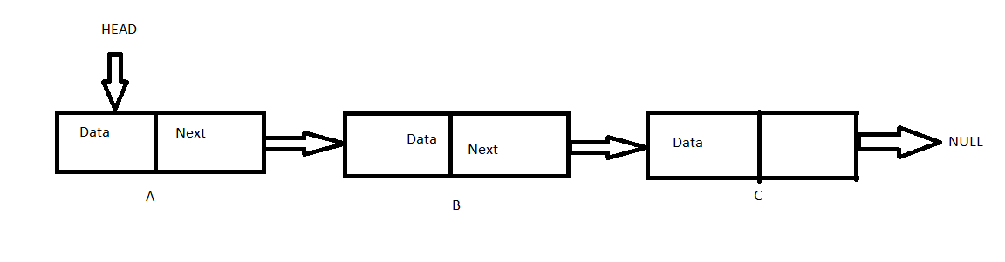

1. Singly linked lists

A **singly linked list** is a type of linked list that is unidirectional, that is, it can be traversed in only one direction from head to the last node (tail).

Each element in a linked list is called a **node**. A single node contains data and a pointer to the next node which helps in maintaining the structure of the list.



1. Doubly linked lists

Each node consists of a data value, a pointer to the next node, and a pointer to the previous node.

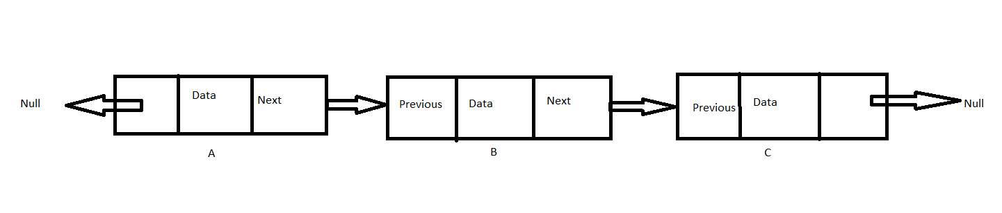

1. Circular linked lists

Circular linked list is a **linked list where all nodes are connected to form a circle**. ... A circular linked list can be a singly circular linked list or doubly circular linked list.

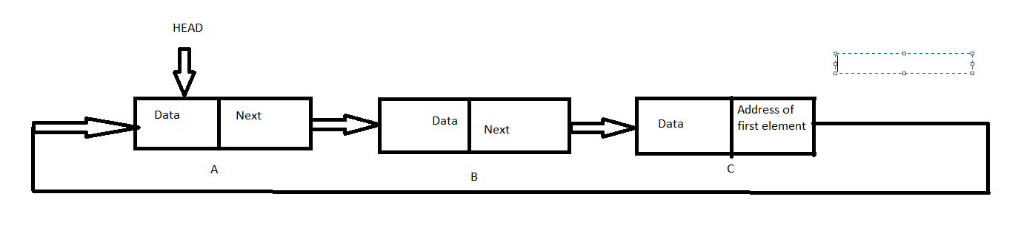

1. Stacks and Queues

Stack is **a container of objects that are inserted and removed according to** the last-in first-out (LIFO) principle.

Queue is a container of objects (a linear collection) that are inserted and removed according to the first-in first-out (FIFO) principle.

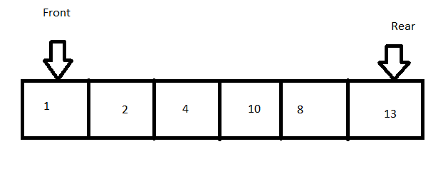 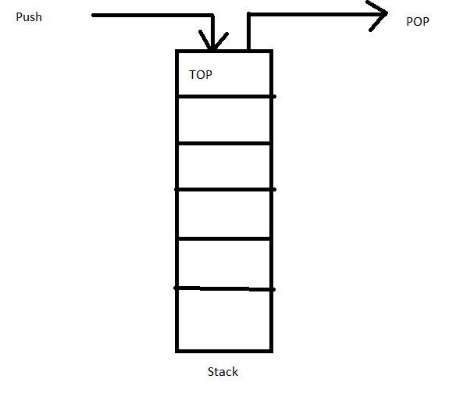

**Session 2**

1. Take array of list apply leaner search

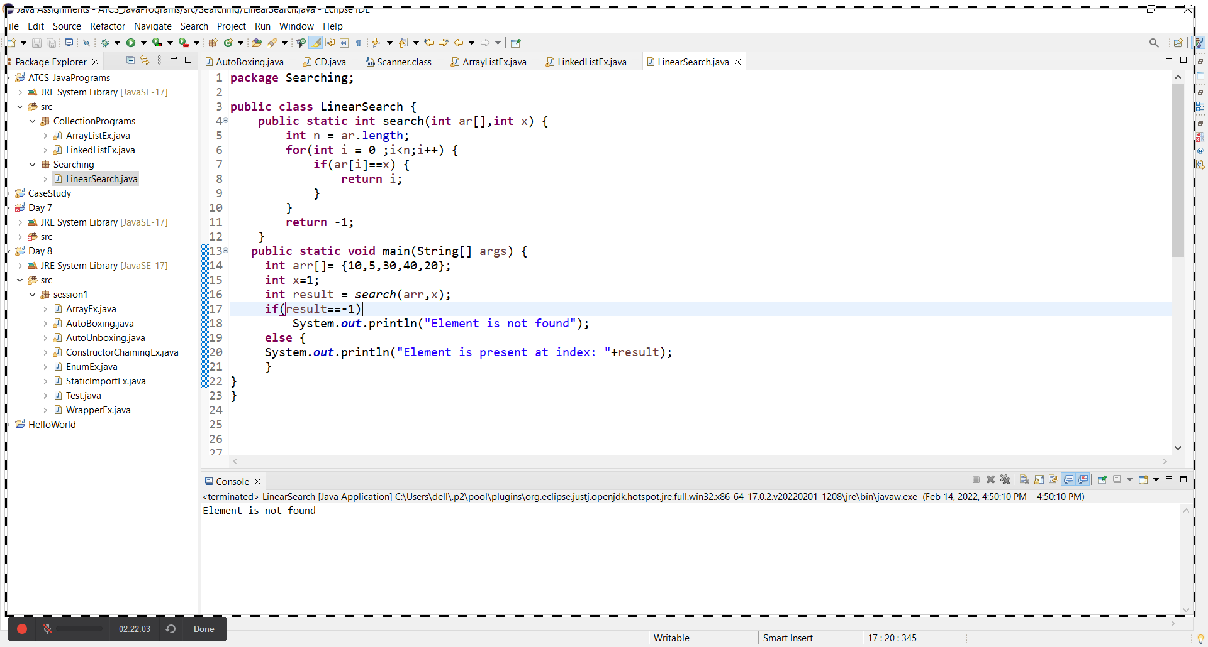

1. Take array of list apply binary search

